24.19: 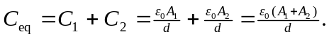 So the combined capacitance for two capacitors in parallel is that of a single capacitor of their combined area 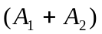 and common plate separation d.

